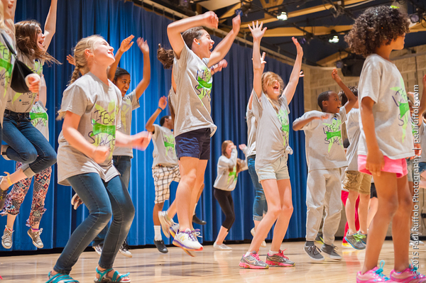
UPAF Notable Women, sponsored by BMO Harris Bank, brings together a powerful group of women dedicated to improving our community through philanthropy, service and advocacy.

UPAF Notable Women make a difference through:
- Uplifting proactive arts education solutions
- Engaging in performing arts service
- Elevating women’s leadership in the community

Women may join UPAF Notable Women with a donation of $1,000 or more. Men may also show their support by contributing on behalf of a Notable Woman in their lives. With your $1,000+ donation to join this distinguished group, you may designate a portion of your gift to one of UPAF's Community Impact Programs – UPAF Bright Minds; UPAF Connect, presented by Northwestern Mutual; or Kasey’s Fund.

Over the past several years, arts education resources in the classroom have seen a dramatic decline throughout Southeastern Wisconsin. For example, there are about 80 art and music specialists for the nearly 80,000 students in Milwaukee Public Schools. Yet studies like the one conducted by the Northwestern Mutual Foundation have proven that:
- Arts education significantly improves a child’s emotional intelligence
- Arts programming also increases confidence, academic performance, innovative and critical thinking, and discipline, particularly for at-risk students

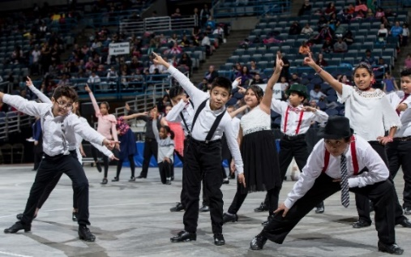

- Invitations to 3 annual arts education-focused programs
- Opportunity to serve on the UPAF Notable Women Council

The founders of UPAF Notable Women engage members to ensure high-quality arts education programs continue to be available through UPAF Member Groups.

Tina Chang | Cathie Madden | Julia Taylor
Mary Dowell | Linda Mellowes | Deanna Tillisch
Sue Frautschi | Jill Morin | Anne Zizzo

To learn more, contact Angela Strelka, Individual Leadership Giving Manager, 414-239-6268.

