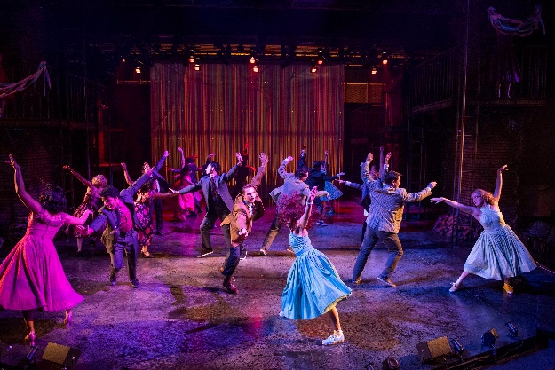
Next Generation UPAF, sponsored by We Energies Foundation, is a group of leaders dedicated to making our community a better place to live, work and play. Members represent the “next generation” in support of, advocacy for and promotion of the performing arts.

Membership is open to donors in their 20s, 30s and 40s and is available in three membership tiers to allow you to engage at the level that is right for you.

Season Samplers are the ideal introduction to our local performing arts scene. For just $20, members get a ticket to a show and access to an exclusive preshow reception.

Speaker series events hosted by area CEOs and dynamic panel discussions offer explorations of the role of performing arts and philanthropy in the community and feature speakers hailing from diverse industries. Past speakers include Steve Booth of Baird, Cecelia Gore of Milwaukee Brewers Foundation and Greg Marcus of Marcus Corporation.

Associate Level - $300
- Introduction to the arts through semi-annual Season Sampler performances and events.

Next Generation Level - $500
- Semi-annual leadership panel events and networking opportunities.

Executive Leadership Level - $1,000
- Access to volunteer leadership roles and engagement with arts leaders through exclusive networking opportunities.

With a gift of $1,000 or more, you may also designate a portion of your gift to one of UPAF’s Community Impact Programs — UPAF Bright Minds, UPAF Connect or Kasey’s Fund.

“I joined Next Gen as I was interested in helping to introduce a younger crowd to the incredible performing arts scene in Milwaukee. To me, this included both philanthropy and performance attendance. After joining Next Gen, I was also able to sit on the Affiliate Grant Review Panel, which is responsible for allocating dollars to performing arts organizations that serve a need in our community, such as Latino Arts or Black Arts MKE. This has been a great experience and helped to educate me on the many programs available in our community thanks to UPAF.” -Becca Schlagenhauf-Stull, Next Generation UPAF Council Member

The Next Generation UPAF Council is a group of leaders committed to cultivating awareness of, promoting philanthropy for and encouraging engagement in the local performing arts scene among younger generations.

Want to get involved and share your skills? Contact us at nextgeneration@upaf.org.

Next Generation UPAF Co-Chairs – 2021

Samantha Maldonado, Principal Financial Group
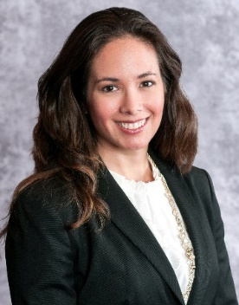
Craig Williams, We Energies
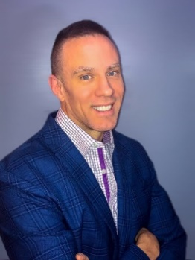

Next Generation UPAF Council Members – 2021

Margaret Edmunds, Baird
Caryn Esten, Froedtert Health
Karen Gamroth, Marcus Corporation
Matt Hills, DeWitt LLP
Kerri Kilbourne, Bostik
Mike King, Zilber, Ltd.

Erica Lythjohan, BMO Harris Bank
Becca Schlagenhauf Stull, Northwestern Mutual Capital
Emily Shircel, Quarles & Brady LLP
Tim Stewart, De Witt LLP
Zachary Wolff, Associated Bank

