Copy and paste the information below into the subject line and body of an email to send to employees at your workplace

Subject Line: Enjoy a special thank you gift from UPAF

Thank you for participating in our UPAF Campaign!

Because of your generosity, the United Performing Arts Fund (UPAF) is able to provide sustaining support to our region’s exceptional performing arts groups, ensuring:

- Entertainment excellence
- Arts education
- Arts accessibility
- Regional economic impact

Your support ensures that the show will go on when our 14 performing arts Member Groups and numerous Affiliate Groups can once again deliver the magic of music, dance and theater for all to enjoy.

As a gift from UPAF, Next Act Theatre has
a special thank you to share with you.

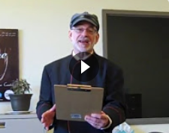

We appreciate your support of UPAF and your commitment to
“A Stage for All.”

