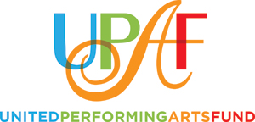
Westside CEO Letter
to Employees

<Date>
Dear Colleague <or Name>:

Please join me in support of the United Performing Arts Fund as we embark on our 2020 Workplace Giving Campaign beginning on <day/date>.

UPAF provides crucial operating funds to our region’s most prominent performing arts groups: First Stage, Florentine Opera Company, Milwaukee Ballet, The Rep, Milwaukee Symphony Orchestra, Skylight Music Theatre and many others.

The performing arts we enjoy make such an immense impact on the quality of our lives. We are fortunate to have this world-class entertainment that is on par with much larger metropolitan areas.

The performing arts employ thousands in the region and boost our economy, benefits that are felt here in Waukesha County. And the 14 Member Groups supported by UPAF provide arts education programming to replace what some of our area schools can’t offer. In Waukesha County alone, UPAF Member Groups provide arts education outreach that impacts almost 50,000 students.

<Company name> is proud to play a role in making world-class performances and outreach efforts accessible to all through its involvement in the 2020 UPAF Campaign. By contributing to UPAF, you are helping to sustain quality performing arts in our community, adding to the economic vitality of our region and supporting arts education programming to hundreds of thousands of students.

Please mark your calendar for our UPAF Campaign Kickoff event on <date/time/place>. This will be your opportunity to hear about how the arts directly affect you and how your donation truly makes our community a better place to live, learn, work and play.

I appreciate your participation and investment in our community.

Sincerely,

<Name>

CEO

