Email 4
Copy and paste the information below into the subject line and body of an email to send to employees at your workplace

Subject Line: UPAF Campaign ends (today/tomorrow/date) — Invest in our community

Thank you to everyone who has contributed to the United Performing Arts Fund (UPAF) Campaign! Your support is critical in ensuring that our region’s exceptional artists and performing arts groups can continue to inspire hope and foster connection — now and into the future. Your gift to UPAF is also an investment in our local economy — the arts create jobs, promote spending, attract talent and make our community a great place to work and live.

Our campaign ends (today/tomorrow/date), so please donate to ensure that Eastern Wisconsin’s exceptional artists and performing arts groups can continue to provide entertainment excellence, serve as an economic engine for our region and educate more than 80,000 local children each year.

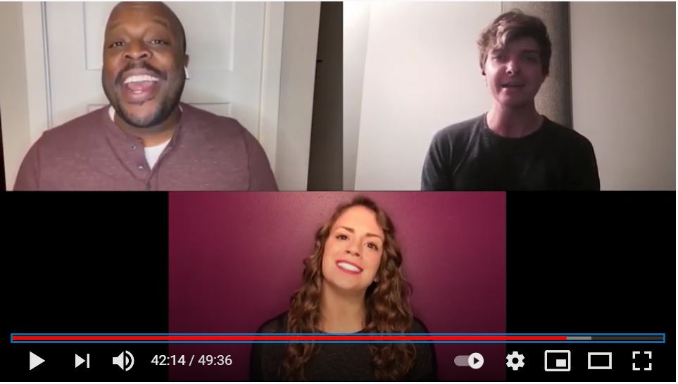
Thank You for the Music, Performed by Skylight
Music Theatre.

For those who haven’t given yet, please play your part and donate today to support performing arts excellence and inclusion: (insert workplace giving site link)

Thank you again to everyone who has supported the UPAF Campaign!

